Excel-to-SQL Semantic Data Agent
Author: Simeen Yunuskhan Pathan
Date: 2025-11-05
Executive Summary:
This project builds an AI-driven agent that converts Excel spreadsheets into structured SQL tables, creates semantic embeddings for schema and values, and answers natural-language queries by generating and executing SQL. The system leverages Azure OpenAI (chat + embeddings) for reasoning and semantic search, ChromaDB for local vector storage, LangGraph for orchestrating the multi-step workflow, and SQLite for a lightweight SQL backend.
Project Github Link:
EY-Activity/5 Nov at main · simeenpathan611-design/EY-Activity

INDEX

Table of Contents | Page No
Problem Statement | 1
Objectives and Scope | 1
Architecture | 2
Technology Stack | 3
System Design | 3
Implementation | 4
Deployment & Running | 5
Testing and Validation | 6
Future Improvements | 6
Security, Privacy and Cost | 6
References | 6
Appendix | 7

- Problem Statement:
Organizations often store critical data in Excel files, making analysis time-consuming and dependent on SQL expertise. This project aims to build an AI-powered agent that automatically converts Excel files into SQL databases and allows users to query data using natural language. By leveraging Azure OpenAI models for SQL generation and understanding, and LangGraph for workflow orchestration, the system enables effortless, intelligent interaction with data—turning raw spreadsheets into actionable insights.

- Objectives:
- To Convert arbitrary Excel files (multiple sheets) into SQL tables automatically.
- To Build semantic embeddings for schema and content for robust, fuzzy matching.
- To Translate natural-language queries to valid SQL using Azure OpenAI.
- To Execute SQL and return results in tabular and human-readable form.
- To Provide a modular, debuggable agent using LangGraph for orchestration.

- Scope:
In scope:
- .xlsx files with tabular sheets (reasonable column headers).
- Local SQLite as the primary database.
- Local ChromaDB for embedding storage (configurable to other stores).
- Azure OpenAI for chat + embedding models.
- CLI and optional Streamlit UI.

Out of scope (initial release):
- Production DBs (Postgres, MySQL) — optional future work.
- Complex ETL transformations (basic column normalization only).
- User authentication and multi-tenant isolation.

- Architecture:

1) High-level components:
- Excel Loader — reads Excel files and writes to SQLite tables.
- Embedder — creates embeddings for table/column texts and stores them in Chroma.
- Query Agent — accepts natural-language questions, retrieves semantic context, prompts Azure
- OpenAI to generate SQL, executes SQL, and formats answers.
- LangGraph Orchestrator — wires nodes together and manages state, checkpoints, and flow.
- Streamlit — upload Excel, index, and chat interface.

2) Diagram:

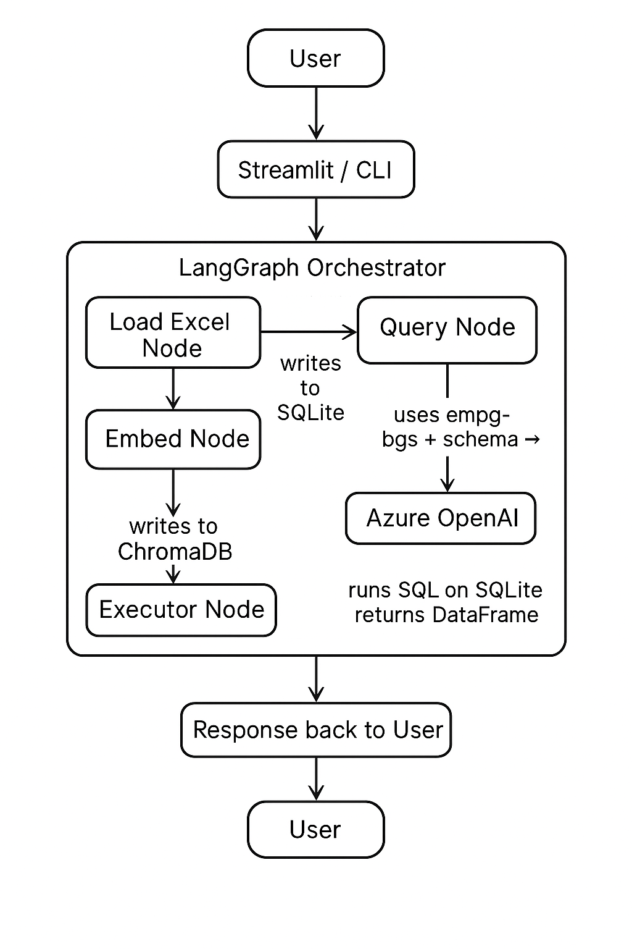

- Technology Stack:
- Language: Python 3.11+
- LLM: Azure OpenAI (chat deployment for SQL generation, embedding deployment for
- vectorization)
- Orchestration: LangGraph
- Vector store: ChromaDB (local; configurable)
- Database: SQLite (data_agent.db)
- Excel parsing: pandas, openpyxl
- UI (optional): Streamlit
- Dev environment: VS Code

- System Design:
1)Data flow:
- User places .xlsx files into excel_files/ or uploads via UI.
- Load Excel Node reads each sheet into a DataFrame and writes to SQLite tables using safe table name conventions.
- Embed Node iterates tables/columns and creates embeddings for column descriptors (and optionally sample row texts) and stores vectors in Chroma.
- Query Node receives a user question, generates an embedding for the question, queries Chroma for relevant schema/context, then builds a prompt containing schema + semantic context and sends it to the Chat model.
- The Chat model returns SQL which is validated and executed on SQLite.
- Results are returned as DataFrame and optionally summarized/explained by the model.

2)Node descriptions (LangGraph):
load_excel: Input: folder path. Output: db_path saved to state.
create_embeddings: Input: db_path . Output: Chroma collection populated.
ask_query: Input: question , db_path . Output: result (rows or error string).

3) Schema and naming conventions:
Table names: <filename>_<sheetname> sanitized to [a-z0-9_]+ .
Column names: lowercased, spaces and special chars replaced with underscores.

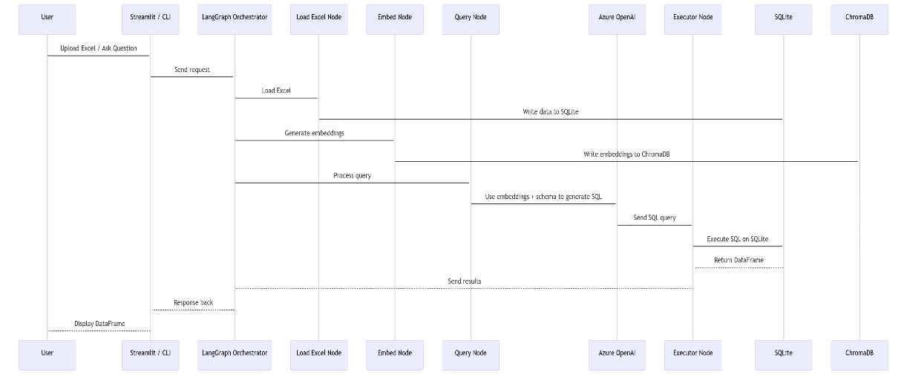

- Implementation:
1)Folder Structure:
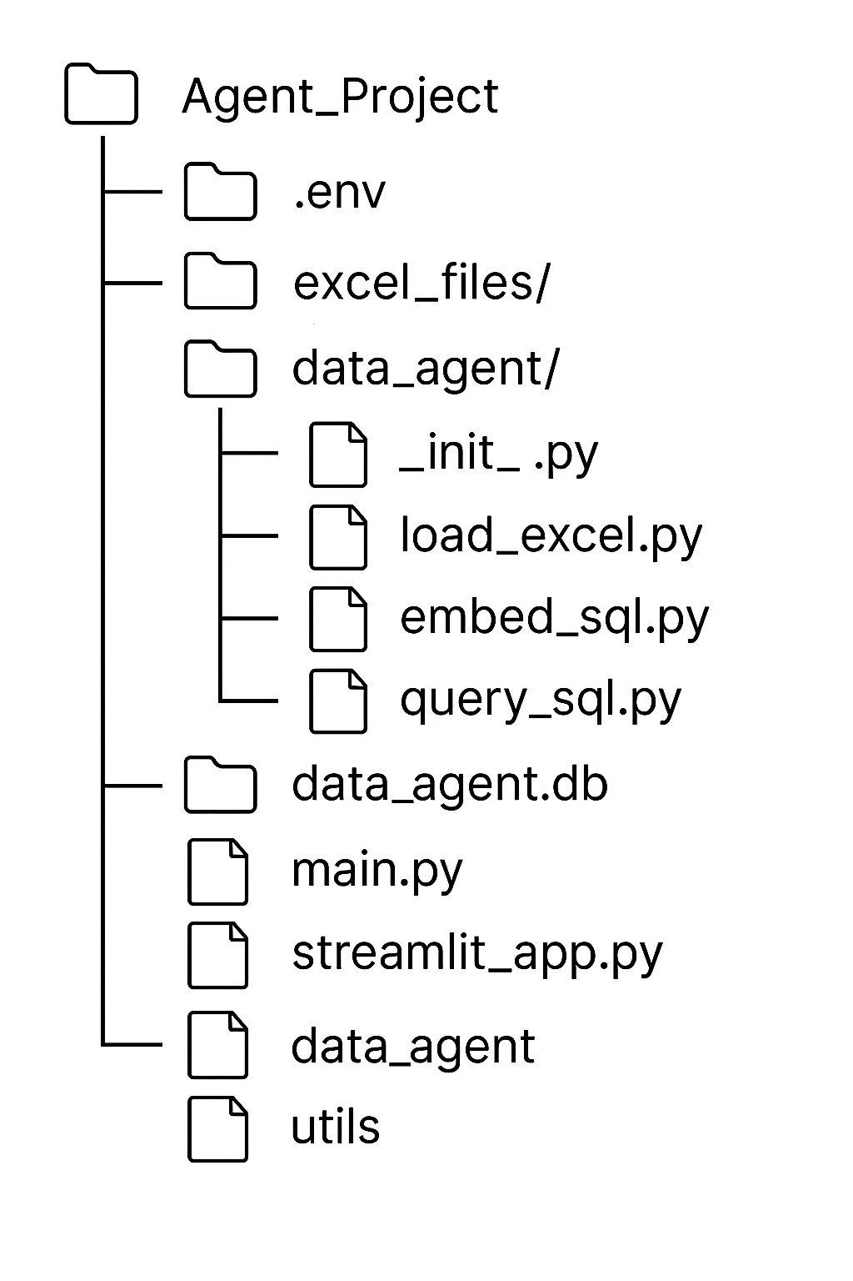

2)Key module responsibilities:
- load_excel.py — convert excel sheets to sqlite tables.
- embed_sql.py — create column-level embeddings and store in Chroma.
- query_sql.py — find relevant context, call Azure OpenAI to produce SQL, run SQL, return result.
- graph_agent.py — define LangGraph state schema, nodes, entry point, and edges.

3)Example code snippets:
Table name sanitization pattern:
import re
clean = re.sub(r"[^0-9a-zA-Z_]+","_", raw_name).lower()

clean = re.sub(r"[^0-9a-zA-Z_]+","_", raw_name).lower()

Prompt skeleton for SQL generation:
You are a data analyst. Database schema: {schema}
Semantic context: {semantic_context}
Question: {question}
Return only a valid SQLite query.

- Deployment & Running:
1)Prerequisites:
- Python 3.11+
- Azure OpenAI resource with chat & embedding deployments
- VS Code (recommended)

2)Environment variables:
See Appendix for a secure .env sample. Place .env in project root.

3)Install:
python -m venv venv
source venv/bin/activate # or .\venv\Scripts\activate (Windows)
pip install -r requirements.txt

4)Run:
python main.py
streamlit run app.py

- Testing and Validation:
- Unit tests: create test Excel files with controlled rows and check that resulting SQL tables exist and column names sanitized.
- Integration tests: automate: load Excel -> create embeddings -> ask fixed questions -> verify correct SQL executed and results match expected output.
- LLM validation: ensure temperature=0 for deterministic SQL generation; add a SQL validator to block destructive commands (no DROP , DELETE without WHERE , etc.).

- Future Improvements:
- Production DB support (Postgres, MySQL).
- Persistent Chroma storage and scalable vector stores (Milvus, Pinecone, Weaviate).
- SQL validation & safe execution sandbox.
- Support for CSV, JSON, Google Sheets connectors.
- Multi-user authentication & RBAC.
- Visualization dashboard for query results and schema explorer.

- Security, Privacy & Cost:
- Security: Do not commit .env . Securely store API keys (Key Vault for production).
- Privacy: Avoid sending PII to LLMs if not required; anonymize data if privacy-sensitive.
- Cost: Monitor Azure OpenAI consumption — embedding and chat calls incur charges. Use small test prompts and batch embedding requests.

- References:
- Azure OpenAI docs
- LangGraph / LangChain docs
- ChromaDB docs
- pandas documentation (read_excel / to_sql)

- Appendix:
1)Sample .env:
AZURE_OPENAI_ENDPOINT=https://YOUR_RESOURCE_NAME.openai.azure.com/
AZURE_OPENAI_KEY=YOUR_AZURE_KEY
OPENAI_API_VERSION=2024-06-01
AZURE_OPENAI_DEPLOYMENT=gpt4o-deployment
AZURE_OPENAI_EMBEDDING_DEPLOYMENT=embeddings-deploy

2) Sample SQL schema (example from sales_data.xlsx ):
Table: sales_data_sheet1
Columns: region, sales_amount, quarter, salesperson

3) Sample prompts:
SQL generation prompt:
You are a senior data analyst. Given the database schema and semantic hints,
write a valid SQLite query that answers the question. Return only SQL.
Schema: {schema}
Context: {context}
Question: {question}

Follow-up prompt for explanation:
Explain the resulting SQL in plain English and summarize the top 3 takeaways
from the result table.

Excel-to-SQL Semantic Data Agent UI:

